**DATA VISUALIZATIONS USING AMAZON S3 AND AMAZON QUICKSIGHT, WORKING WITH A LARGE DATASET OF BEST-SELLING AMAZON PRODUCTS**

**STEPS:**

1. First we have to download the Amazon bestseller product dataset which can be obtain from github link:

<https://github.com/Asmit123/Amazon-data-visualization-using-AWS>

1. We also have to create a manifest.json file which is also uploaded in the same github link.
2. Then we go to the AWS website and sign in.
3. We start S3 service in the AWS, create a new bucket and upload the Amazon bestseller product dataset and manifest.json file.

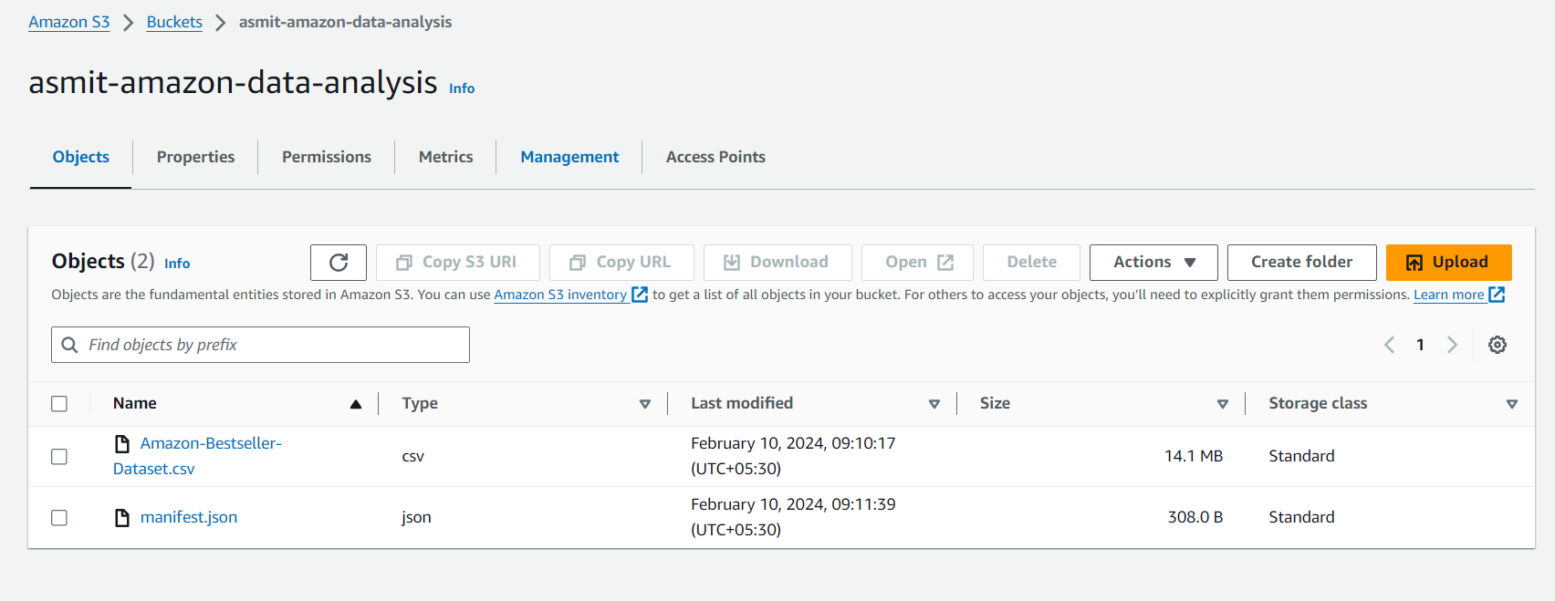

1. Open the AWS Quicksight in new tab because we need the S3 tab open then It will show you to create new quicksight account follow the step following :

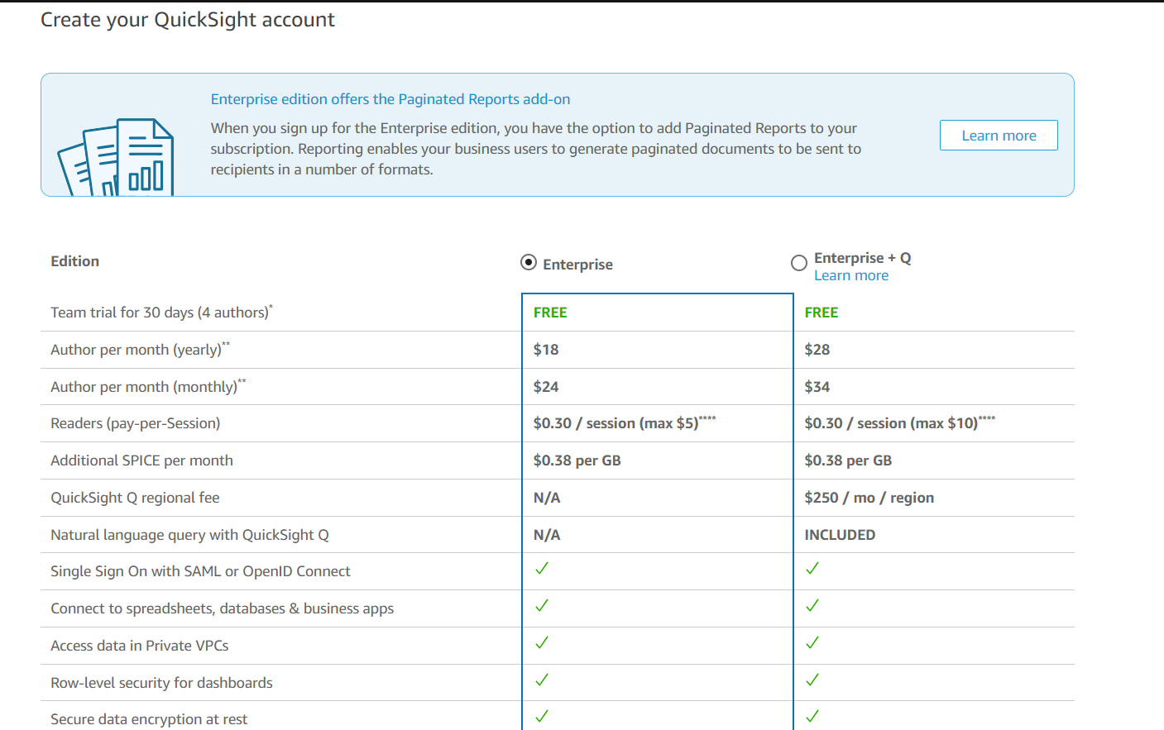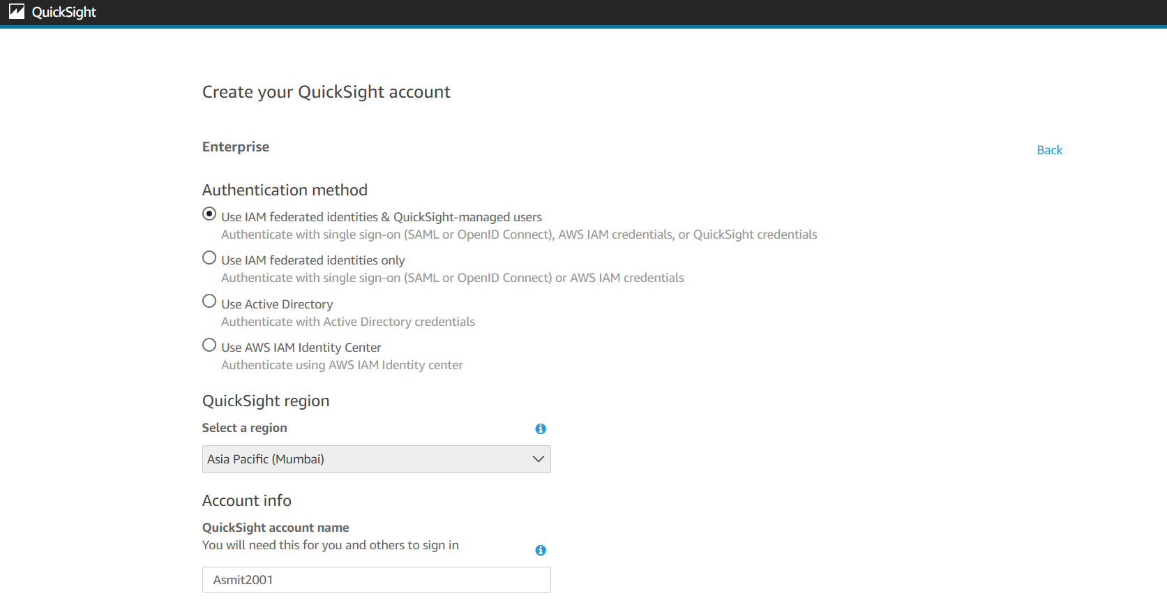

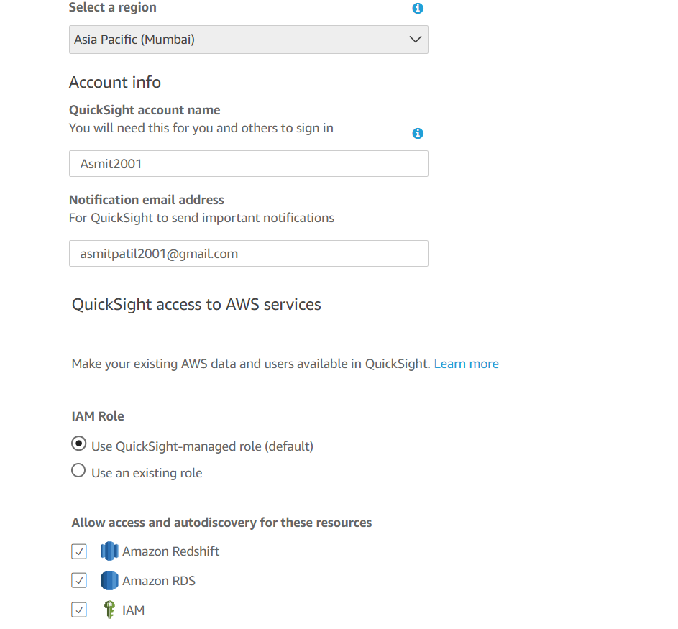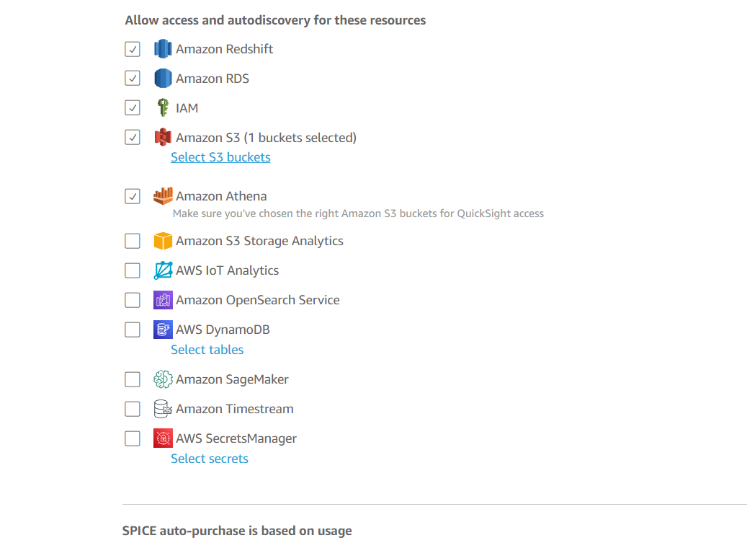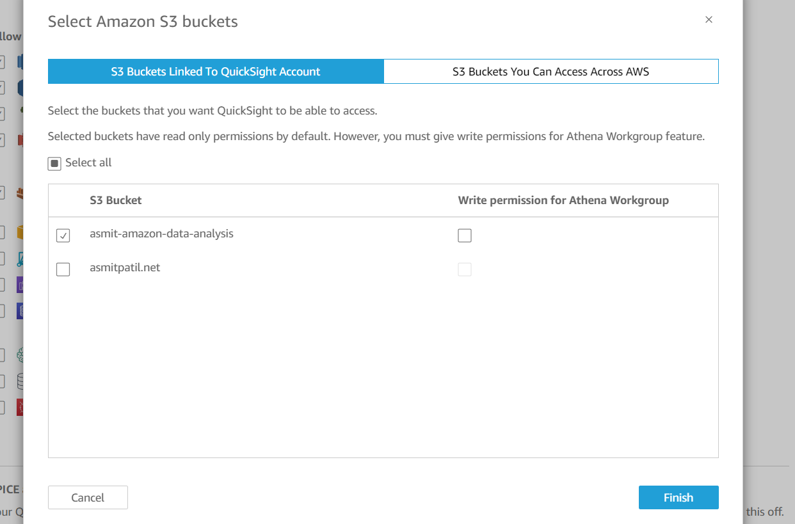

1. Then It will open the Quicksight portal, go to the datasets.

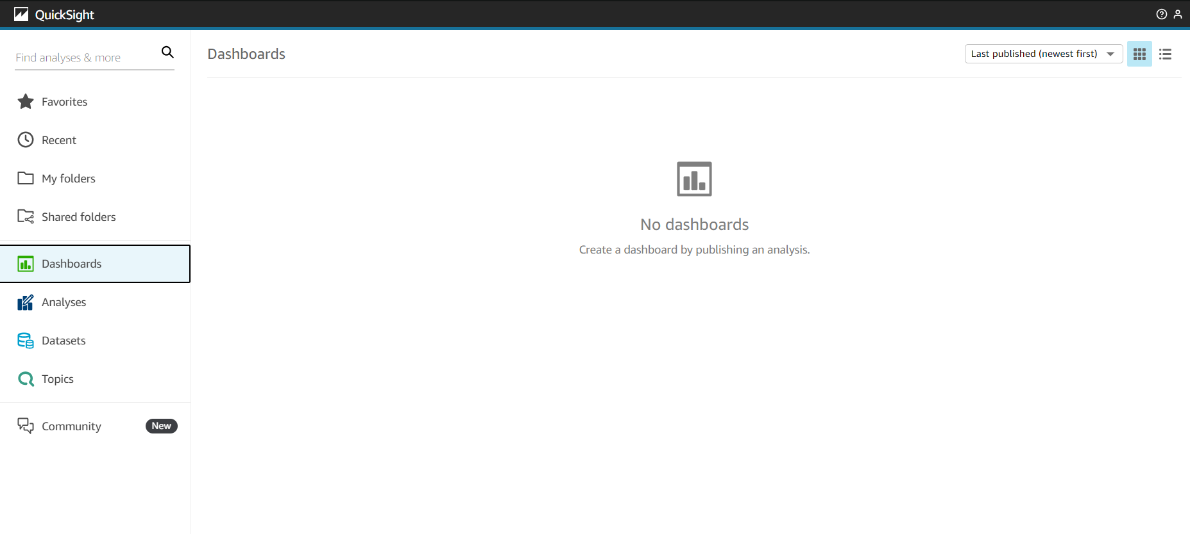

1. Click on the new dataset.

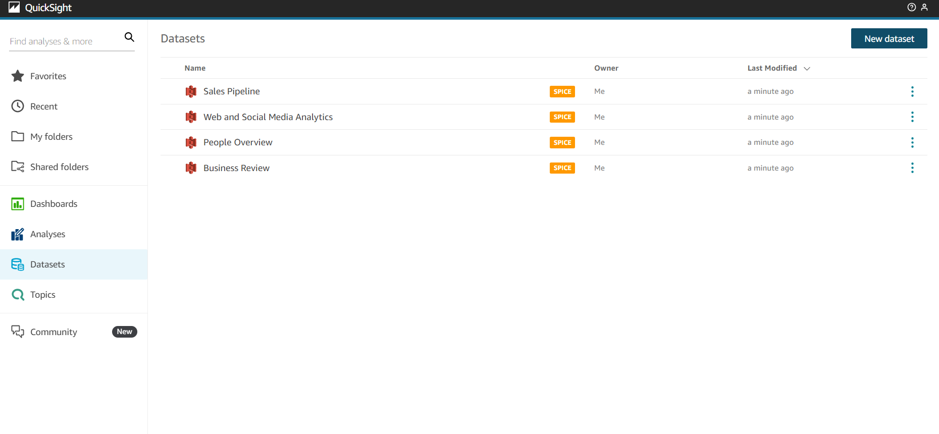

1. Click on S3.

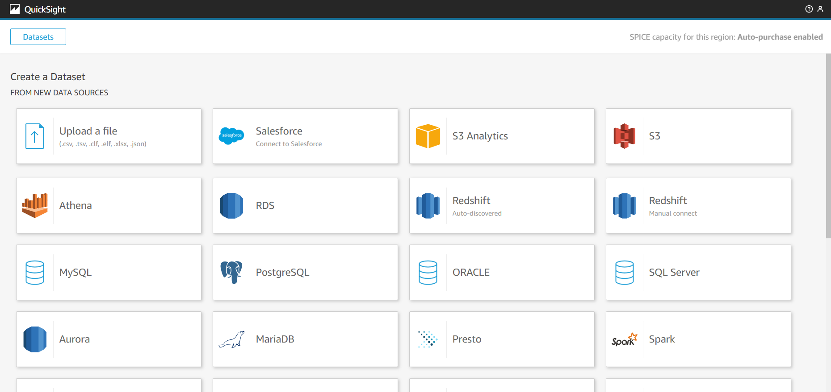

1. Go to the S3 tab copy the manifest.json files S3 url.

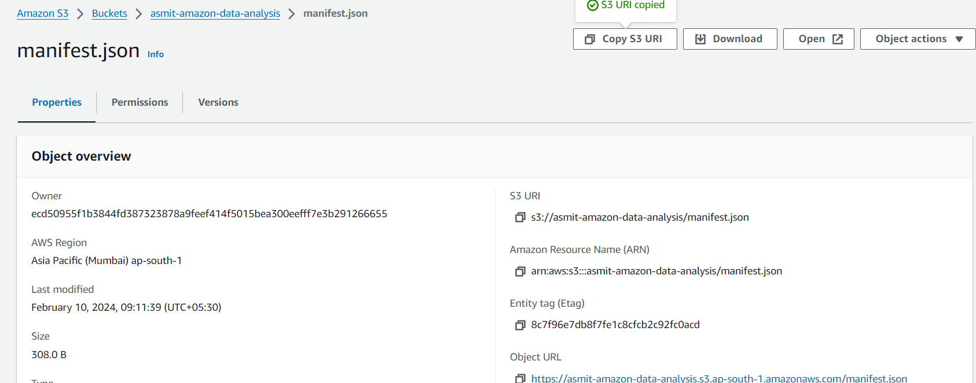

1. It will show the “new S3 data source” box, add name and manifest.json url.

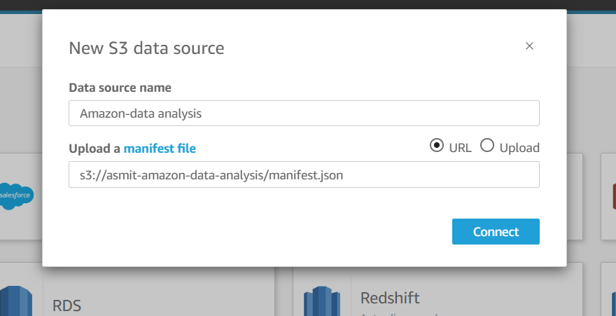

1. Then It will show you the “finish dataset creation” box and click on visualize.

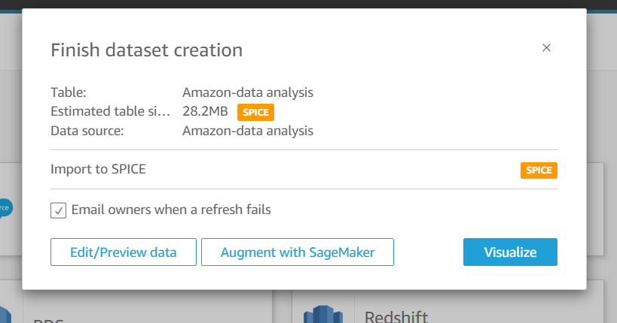

1. It will show us the “new sheet” and click on create.

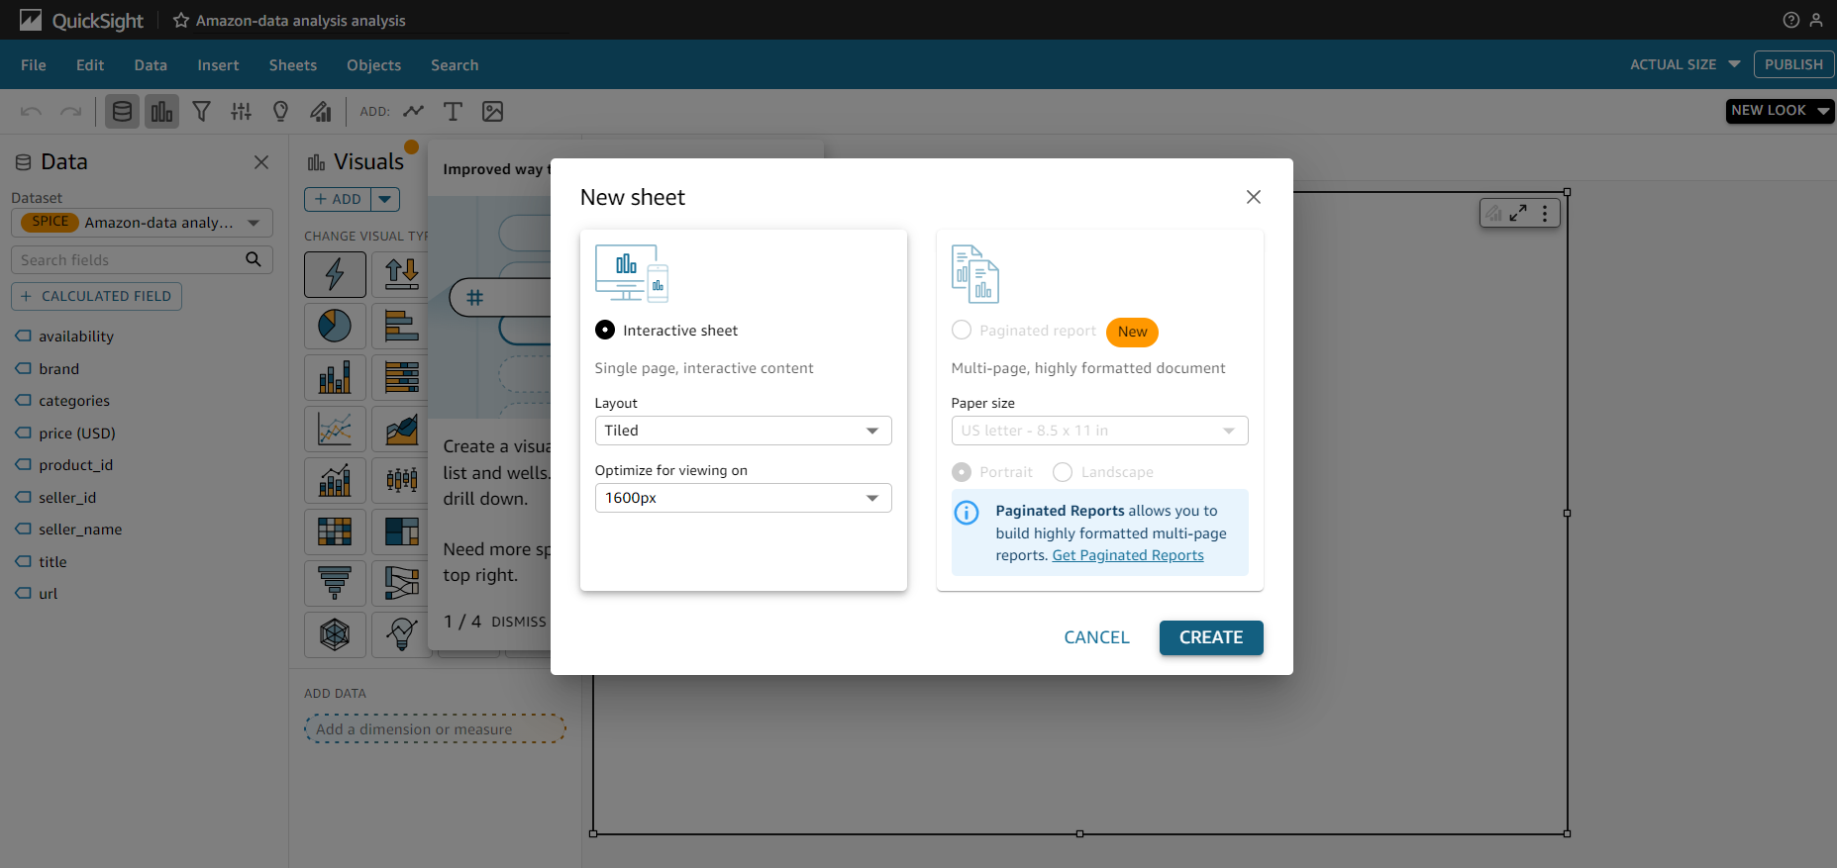

1. Then you can start visualizing the dataset.

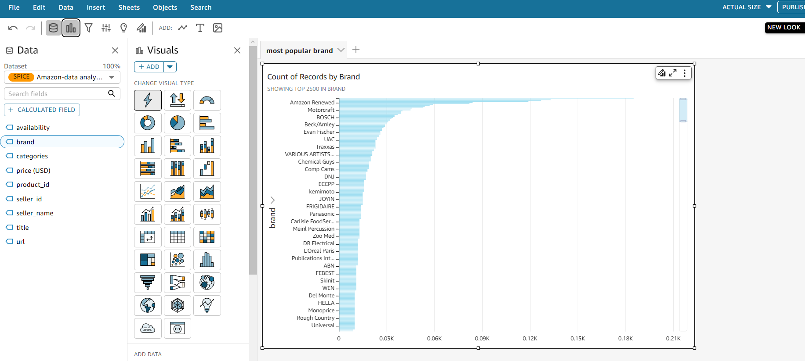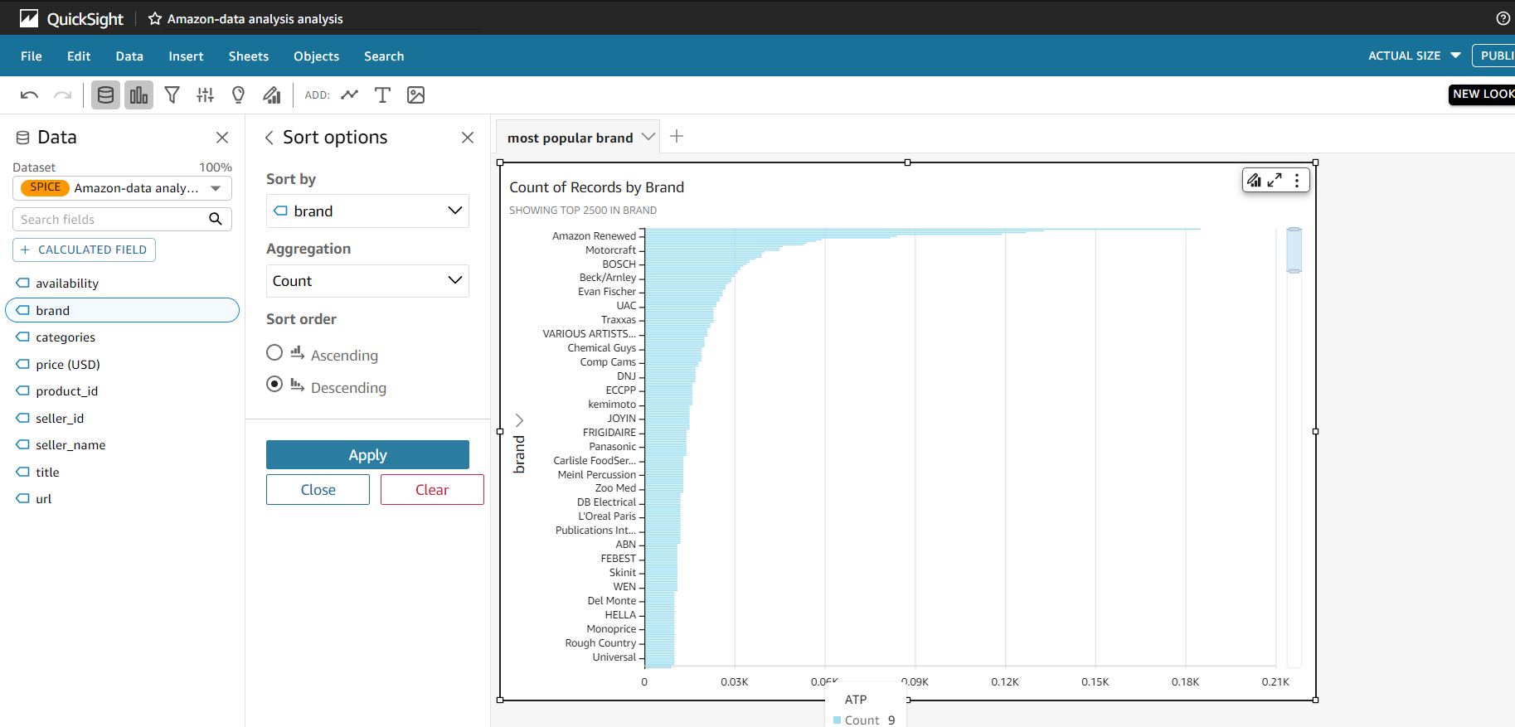

1. Then creating pages visualizing the dataset you can publish all this which will be shown in the dashboard.

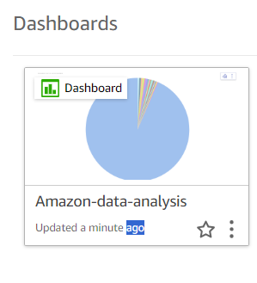

1. This are some visualization which I created using AWS quicksight and S3.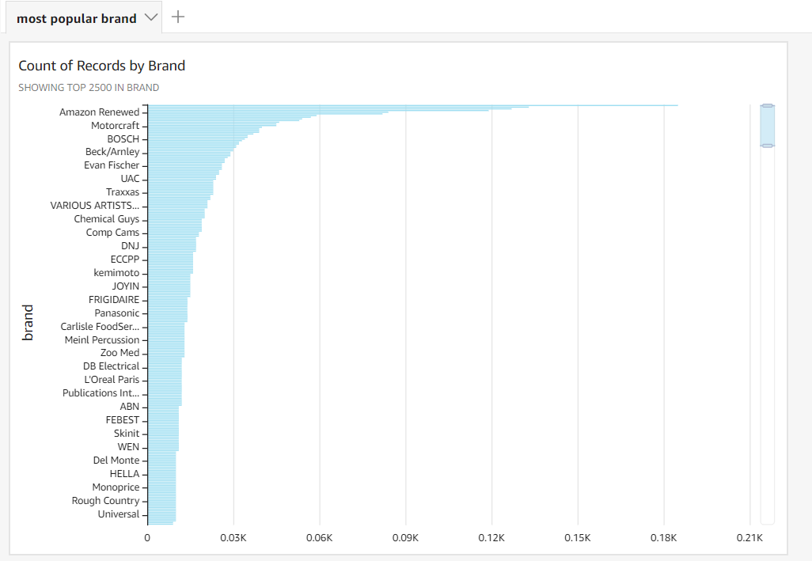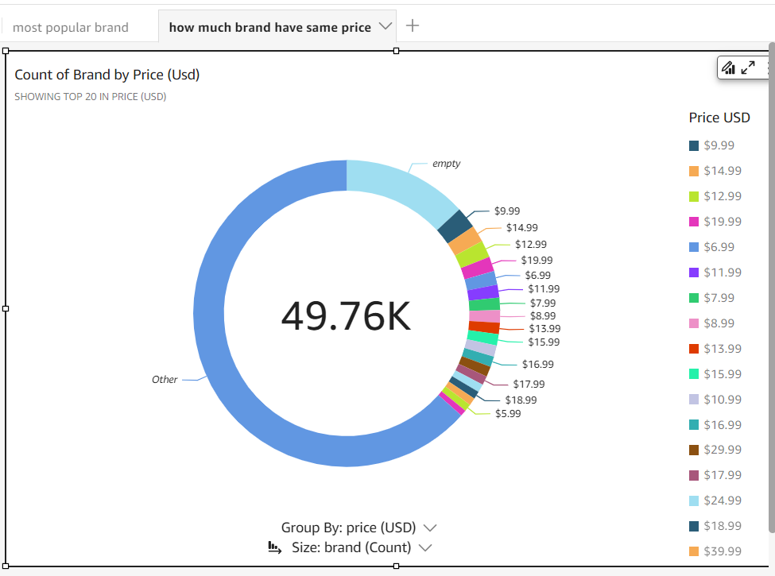

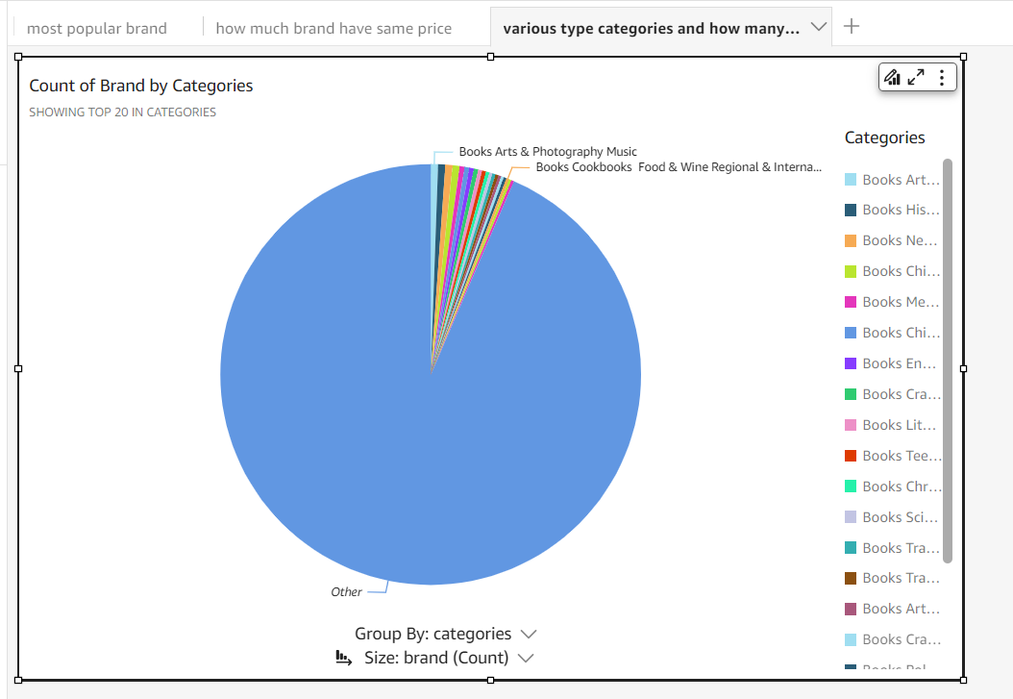

**Summary:**

Leveraging Amazon S3 and Amazon QuickSight, this project focuses on data visualizations for a substantial dataset of best-selling Amazon products. Uncover insights, patterns, and trends within the data to inform strategic decisions and enhance understanding of customer preferences and market dynamics.